PRACTICLE-9

Objective:- To understand how to design and create a Virtual Private Cloud (VPC) in AWS.

Step1. Open VPC Dashboard
- Sign in to AWS Console.
- Search VPC in the services search bar.
- Click VPC Dashboard.
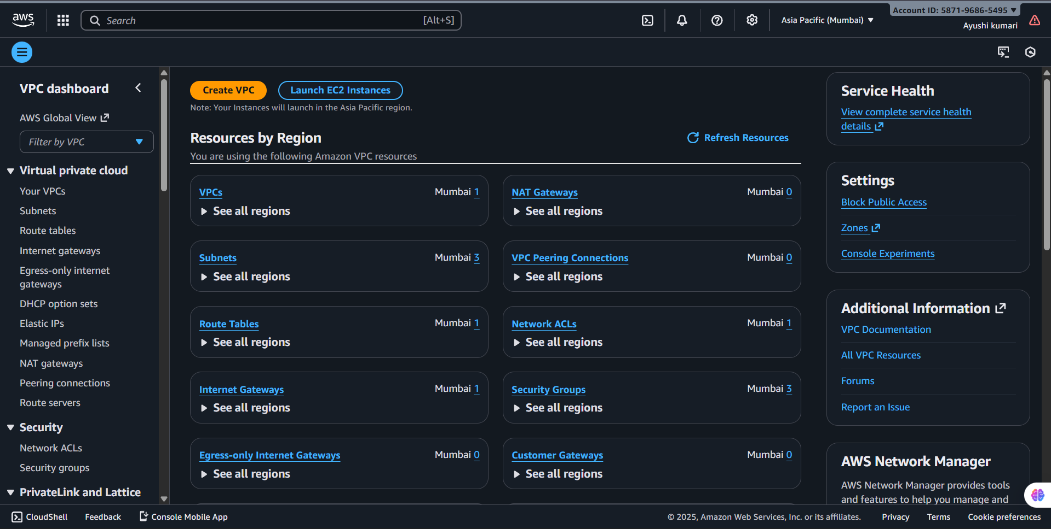

Step2. Start Creating a VPC
- On the left menu, select Your VPCs.
- Click Create VPC.
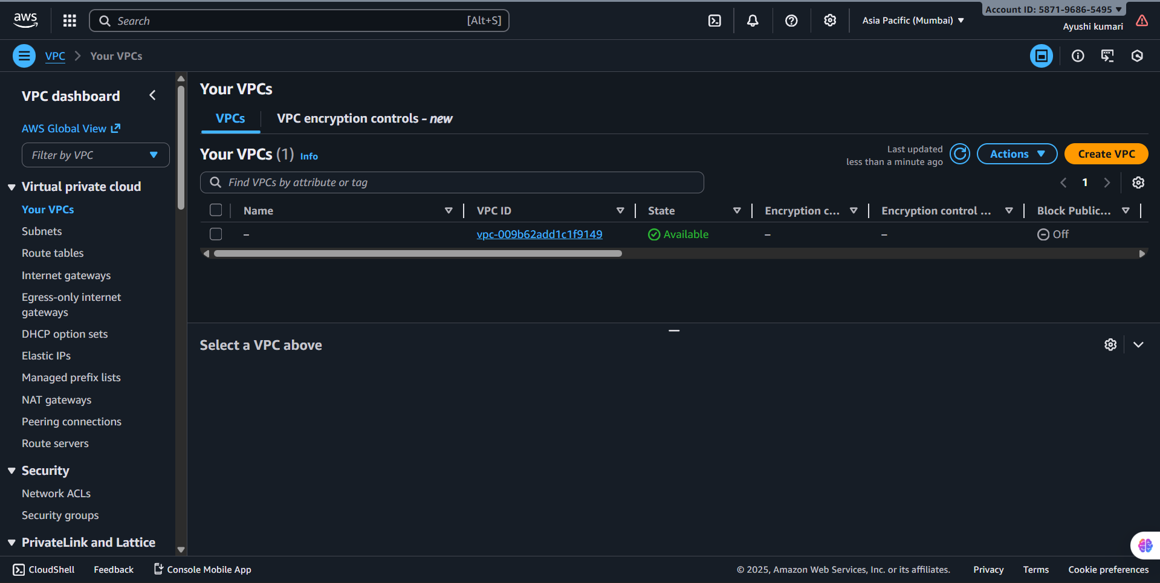

Step3. Select VPC Creation Method
You will get two options:
- VPC Only → Create VPC manually
- VPC and more → Automatically create VPC with subnets, IGW, route tables, etc.
Choose VPC Only for full control.

Step 4. Configure VPC Settings
Fill the form:

(a) Name tag
- Example: MyVPC

(b) IPv4 CIDR Block
- Example: 10.0.0.0/16

(c) IPv6 CIDR Block
- Choose No IPv6 CIDR block (optional)

(d) Tenancy
- Default (recommended)
Click Create VPC.
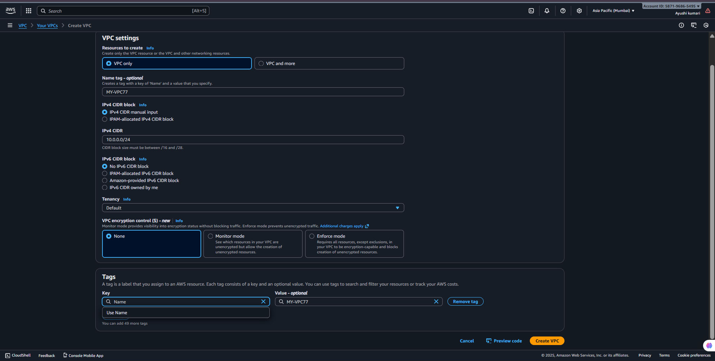
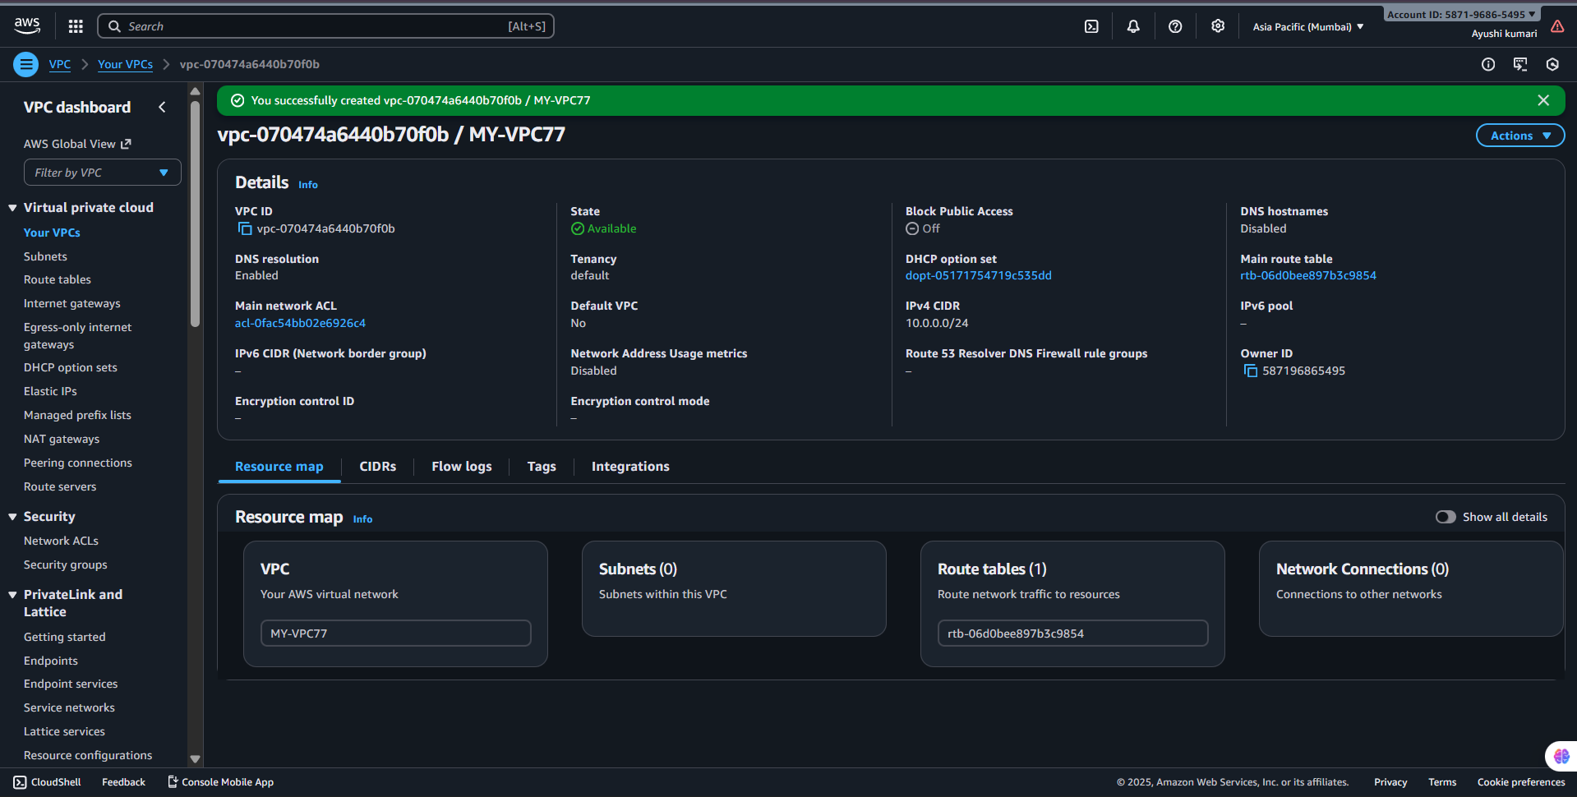

Step 5. Create Subnets
- On the left side, click Subnets → Create subnet.
- Select your VPC.
- Add at least two subnets:
  - Public → 10.0.1.0/24
  - Private → 10.0.2.0/24
- Choose different Availability Zones.
Click Create Subnet.

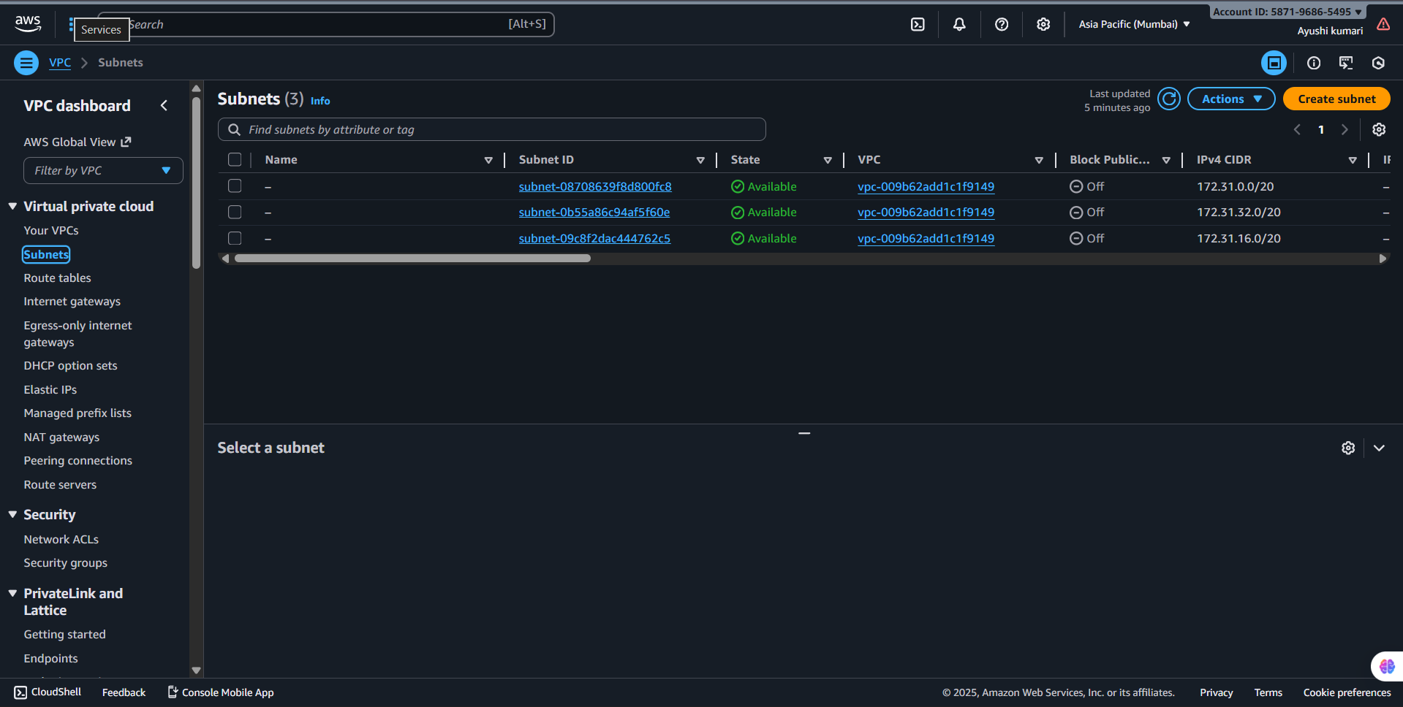
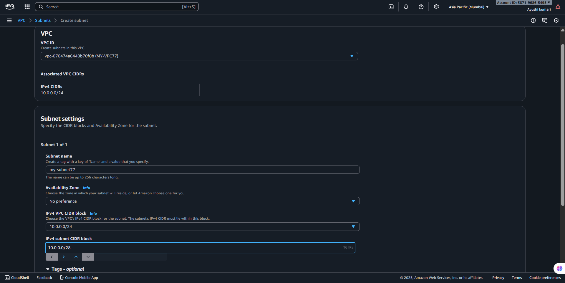
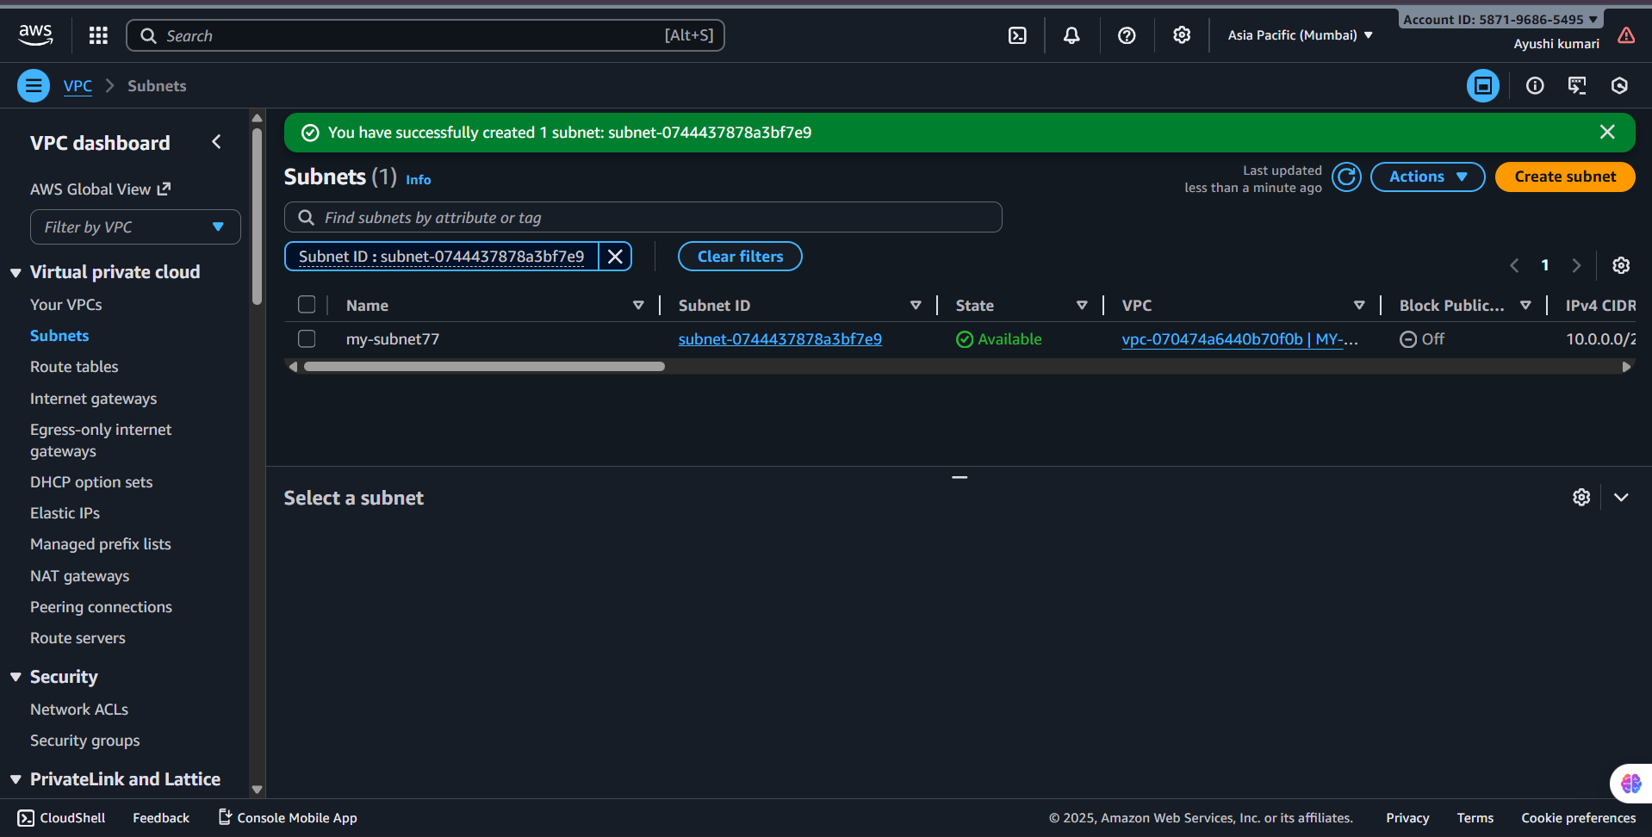

Step 6. Create an Internet Gateway (IGW)
- Click Internet Gateways → Create IGW.
- Name it e.g., MyIGW.
- After creation, select it → click Attach to VPC → choose your VPC.
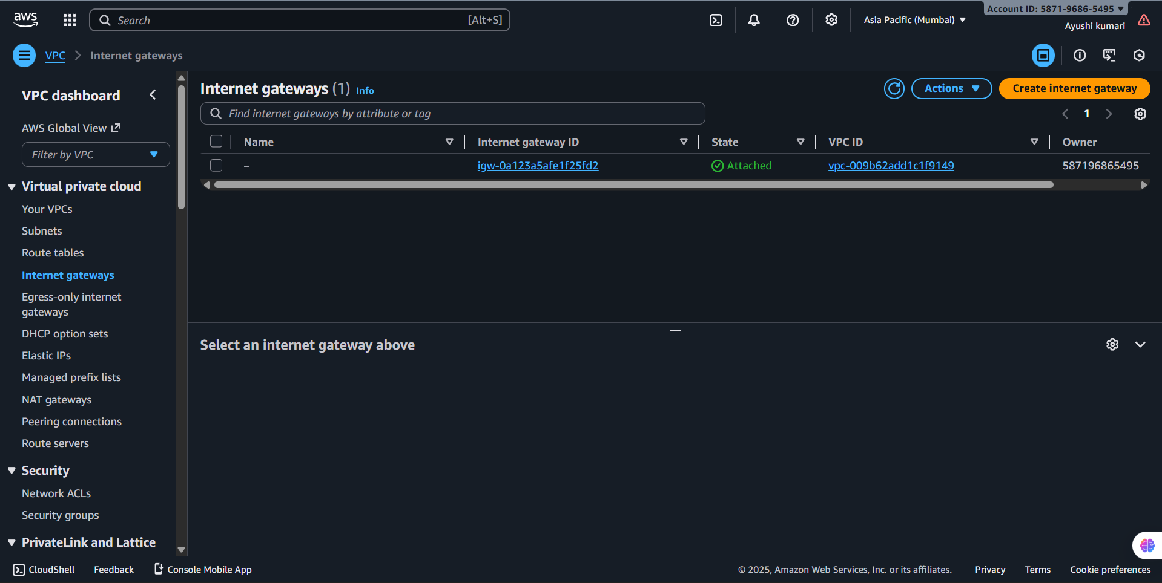
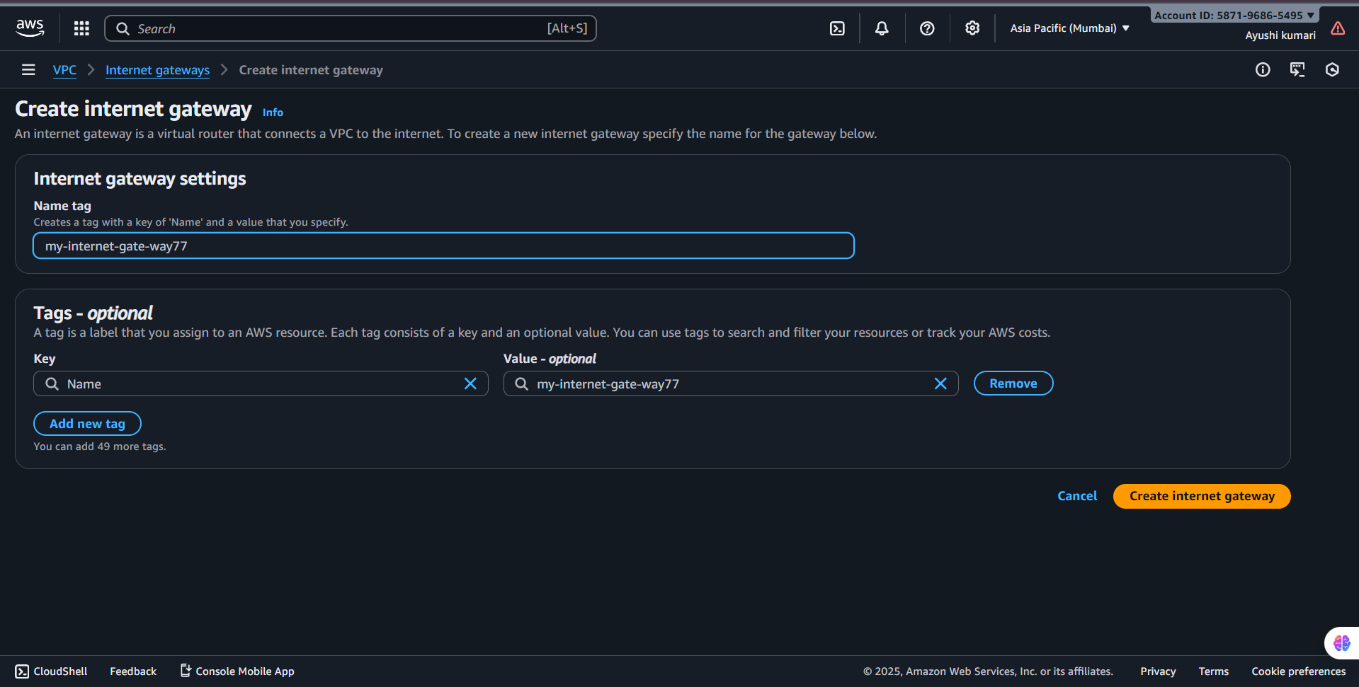
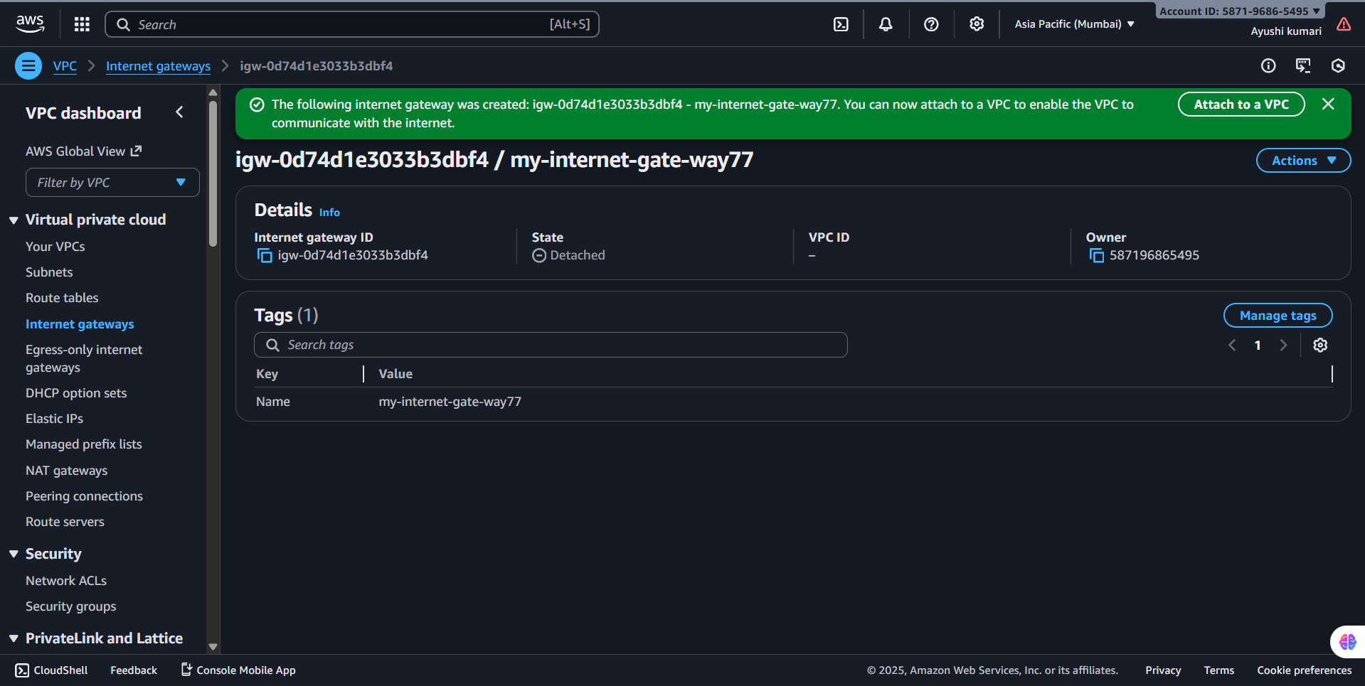
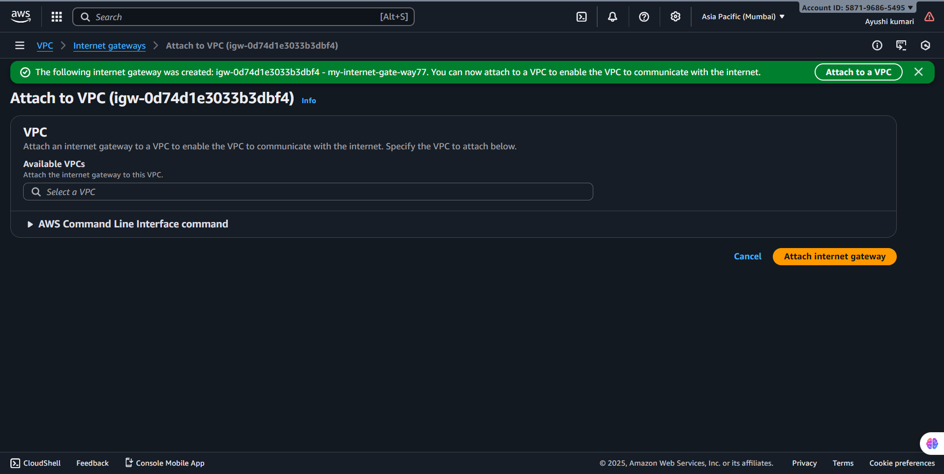
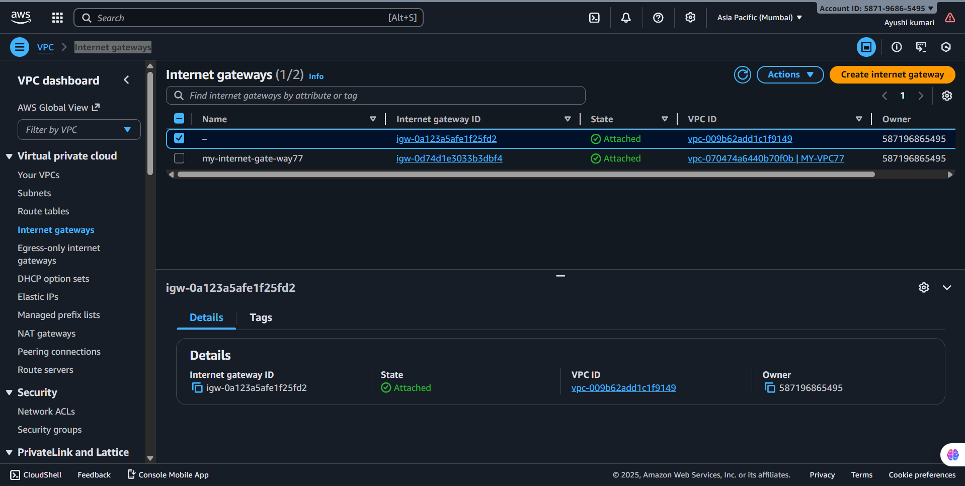

Step 7. Configure Route Tables

Public Route Table
- Go to Route Tables → Create route table.
- Name: PublicRT.
- Select your VPC and create.
- Go to Routes → Edit → Add route:
  - Destination: 0.0.0.0/0
  - Target: Internet Gateway
- Go to Subnet Associations → Associate with public subnet.

Private Route Table
- Create another route table named PrivateRT.
- Associate it with private subnet (no internet route).
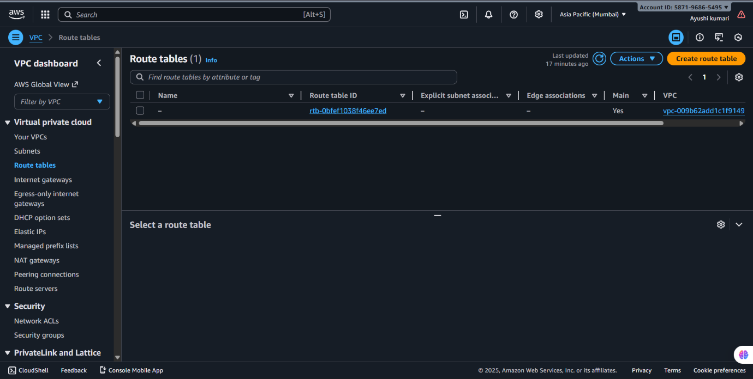
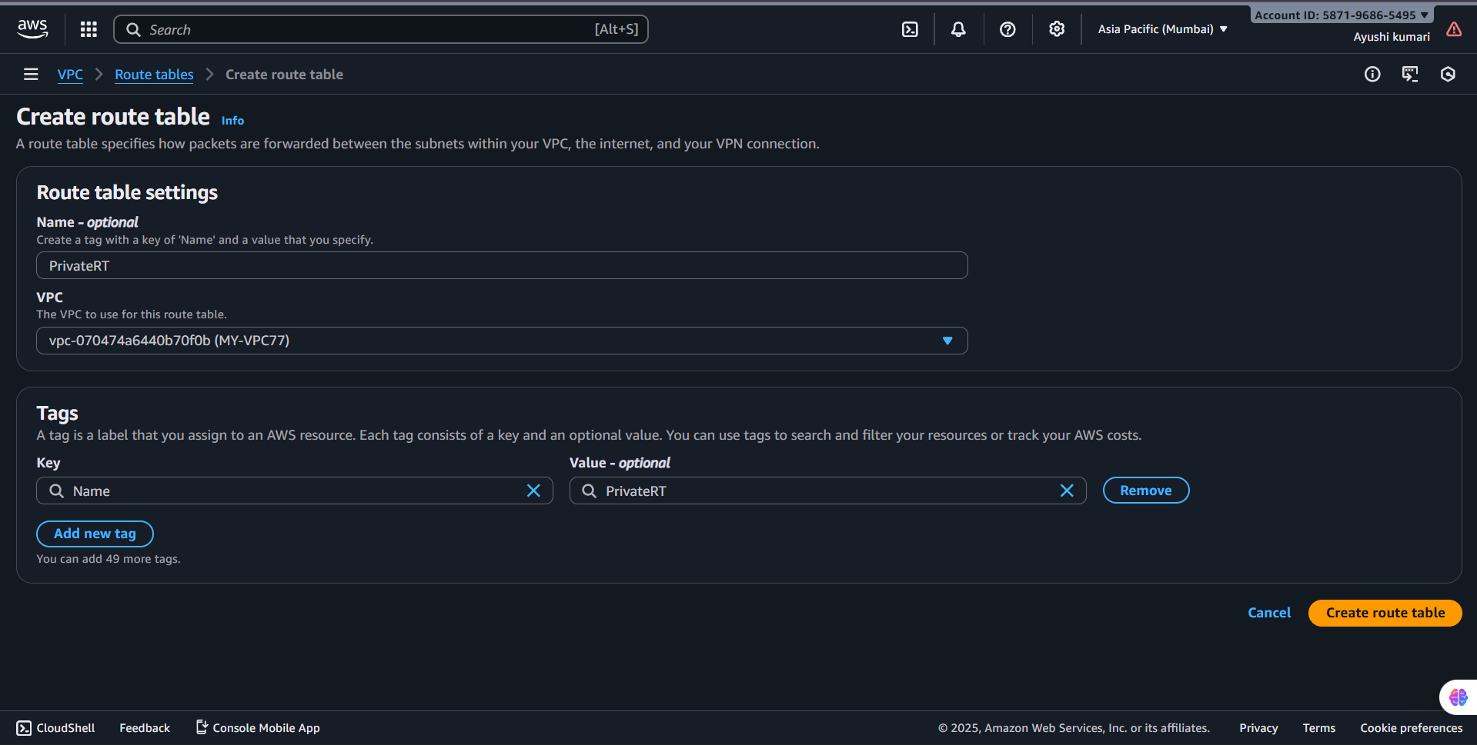
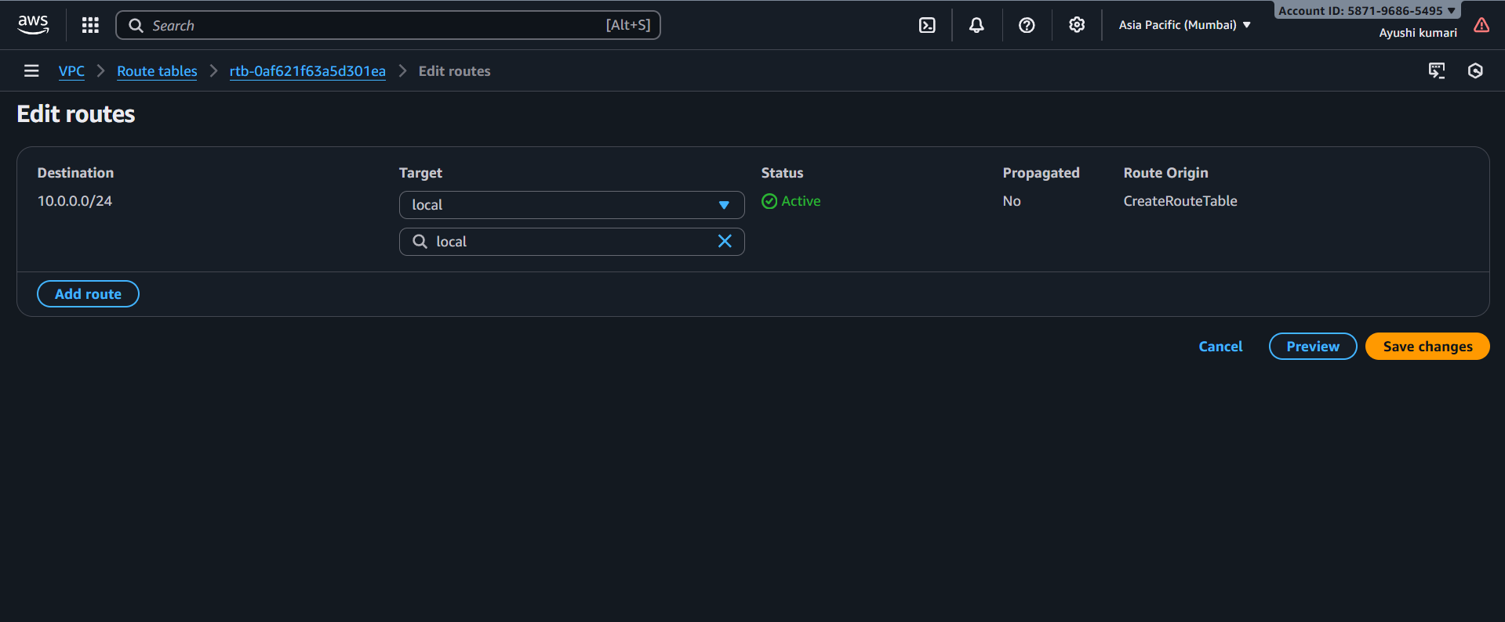

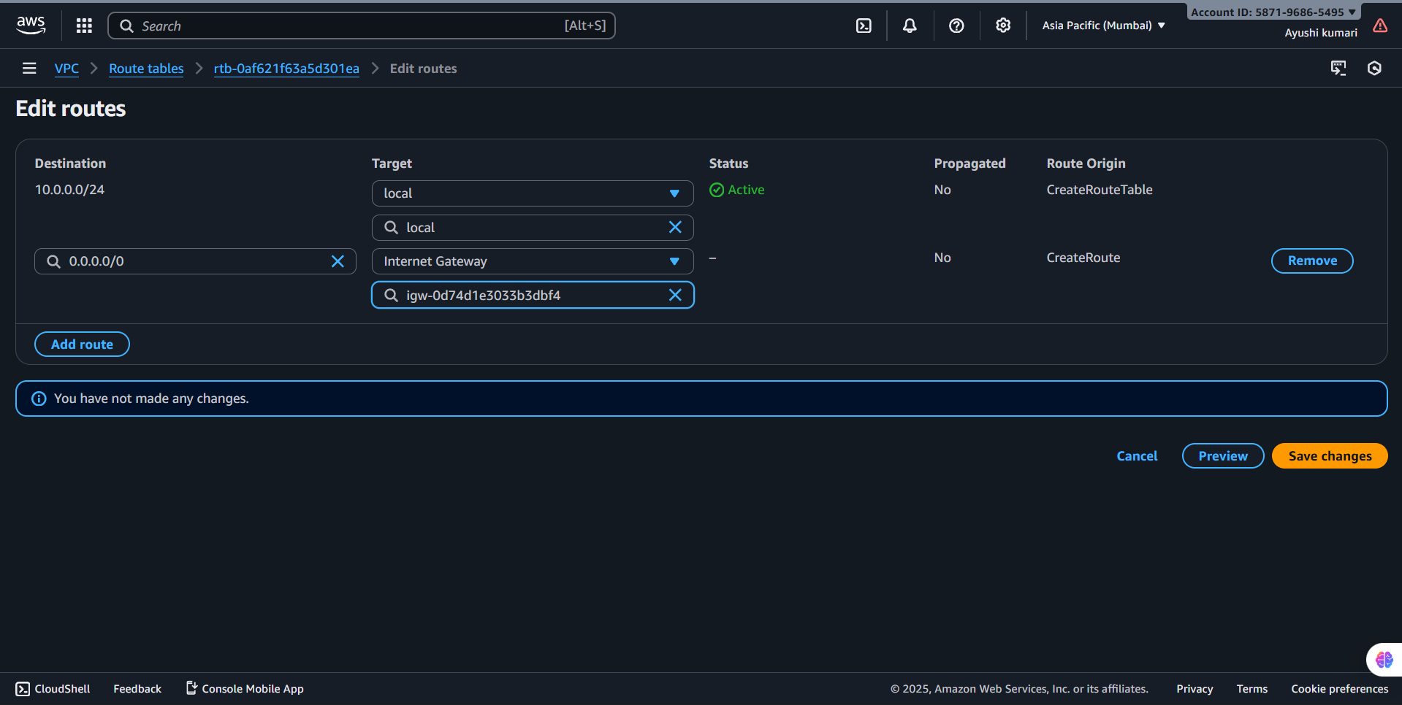
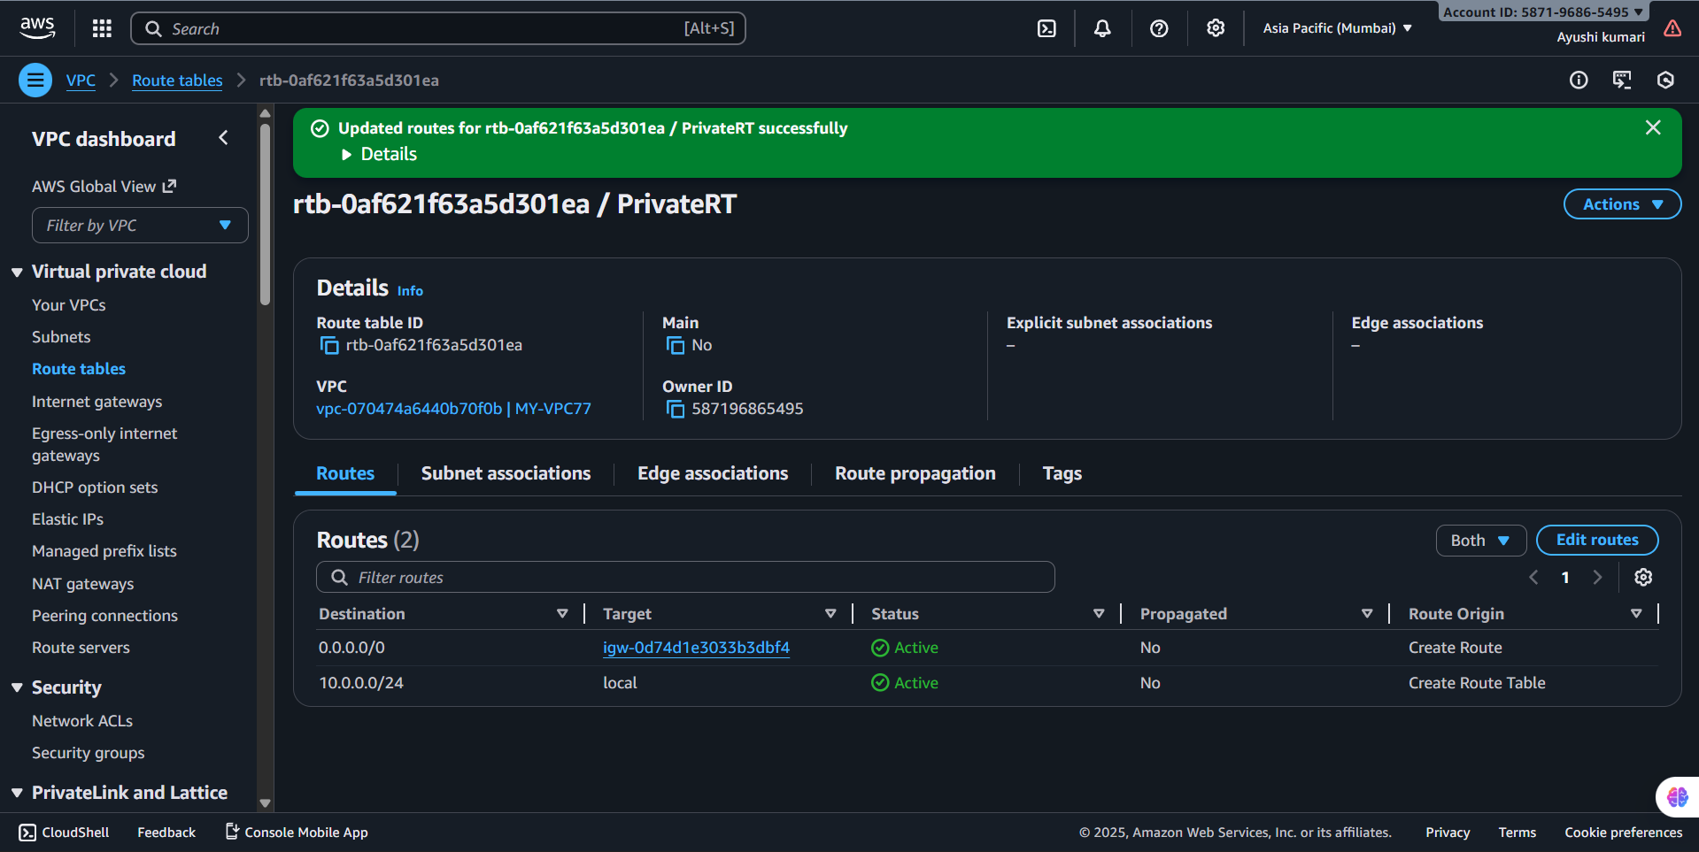

Step 8. Create a NAT Gateway (Optional for private subnet internet)
- Go to NAT Gateways → Create NAT Gateway.
- Select:
  - Subnet: Public subnet
  - Allocate Elastic IP
- Update PrivateRT → Routes to:
  - Destination: 0.0.0.0/0
  - Target: NAT Gateway
